UNIVERSITY OF MAKENI

SYLVANUS KOROMA CAMPUS

YONI



**TEXT-BASED ADVENTURE GAME**

**BY:**

ISATU MAGDALENE KAMARA 4341

EMMANUEL F. BANGURA 2894

**Summitted to:** Mr. Ibrahim Kalokoh

Date: 10th April, 2021

Abstract

This is a python-based project for a simple version of an old-fashioned text-based adventure game. The is an electronic game type that uses text-based user interface, that is, the user interface employs a set of encoded characters such as ASCII instead of bitmap or vector graphics. The game gives players a description of what’s happening, and then asks them to make a choice. Based on the choice which the player chooses, something happens depending on choice the player made. The game also includes some random factors, so that it’s a little different from each time. The game has conditions for winning and losing. The main objective of this project is to implement the coding skills that we have learnt throughout this semester’s python classes.

Table of content

Introduction……………………………………………………………………………………1

Background……………………………………………………………………………………1

Implementation………………………………………………………………………………2-4

Result(s)………………………………………………………………………………………5-6

Conclusion……………………………………………………………………………………….6

References……………………………………………………………………………………….6

**Introduction**

The purpose of this section is to give an introduction of the text-based adventure game project and a motivation to why it is useful.

**Background**

Every year, hundreds of commercial computer games are released. Today many games can present close to photo-realistic graphics, which is the ultimate goal to reach for many game programmers. As we are close to perfect graphics, the step between good and bad graphics are getting smaller and smaller, which means the significance of the same has been reduced.

To create a useful game you need something more, you need a fascinating and interesting story. Unfortunately, there are not many people competent enough to write interesting stories in the gaming industry.

Therefore, in this project, we firstly created a beautiful story for this adventure game and turn this story into a game by suing python programming language. Recently, text adventure games have made a huge comeback. Such games help to build solid knowledge and understanding of Python.

**Description of the Text-based adventure game**

The story of the game revolves around adventure. Theplayers take the role of an unnamed adventurer who is trapped in an unknown location. For our case, **“thick dark forest”**. To progress, players type in various contextual commands in reaction to the story that is written out for them. Players will encounter multiple items and enemies throughout their quest to escape, and it is up to the player's own intuition to use custom typed commands to escape the dangers. For our case, the danger is a fictional humanoid monster called **“orc**”.

**The Aim of the project is as follows:**

* The game gives players a description of what's happening, and then asks them to make a choice.
* Something different happens depending on the choice the player made.
* The game also includes some random factors, so that it's a little different each time.
* The game has conditions for winning and losing

**Implementation**

This section explains the languages/tools used, flow chart that show how data flows through the program and finally screenshots and explanation of code snippets. Creating text-based games are one of the most basic uses of Python, which is a great starting place for anyone wanting to learn

**Languages/tools used**

* Python
* Git
* Jupyter Notebook (Anaconda 3)
* Visual Code Editor

**Screenshots of Code Snippets**

The code below is well commented for easy understanding and readability. The first line imports the time module and the rest of the other lines are to figure out how the player might respond.

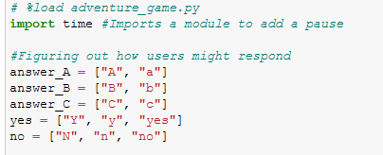

This code explains the introduction scenario of the game

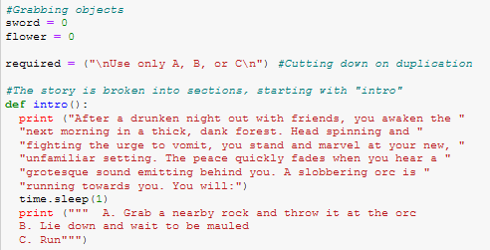

The rest of the screenshot code below make sense, such as **if, elif**, **and else statements**. The code makes the text-based game dynamic, and how the user answers the questions. If a particular answer is given, the user will be branched to a separate section. Now, our code only scratches the surface of branching.

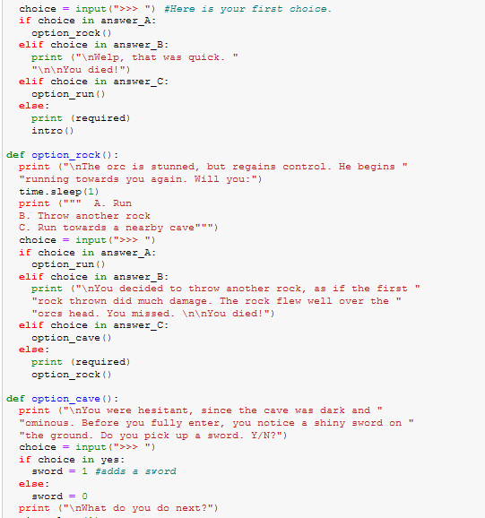

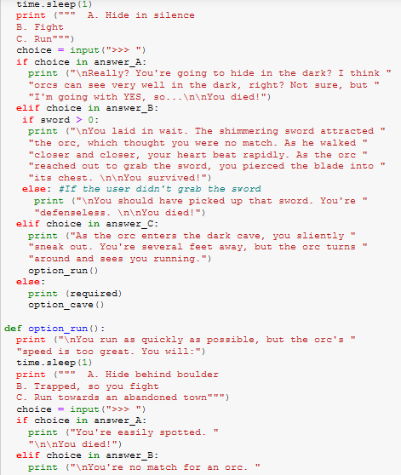

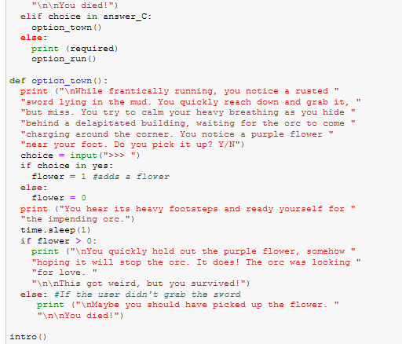

**Results**

The result of this project a functional executable text-based adventure game written in python programming language. Below are screenshots of the result when the code is executed.

**The first result displays a winner after the game has and the orc was deafeated**

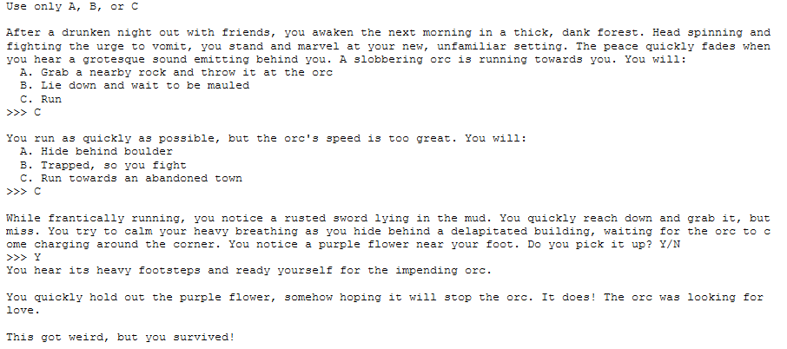

**The second result below shows that the adventurer lost the game**

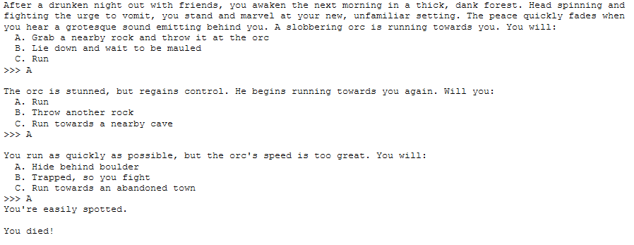

**Flow Chart**

Below is a flowchart to make the branching a little easier to understand.

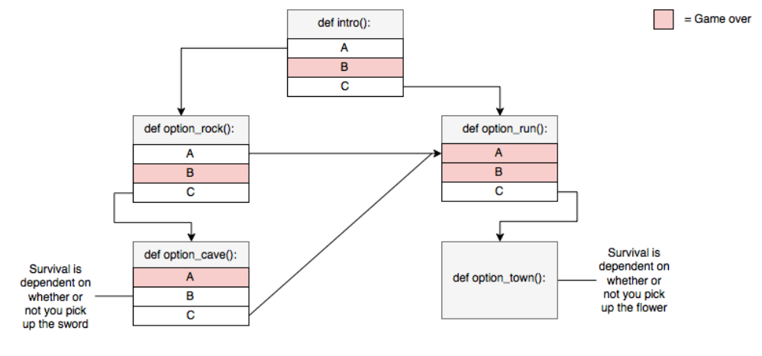

**Conclusion**

This text-based adventure game served as based line for us to understand the implementation of certain concept of Python Programming language. The game is based on characters. The answer you the player chooses determines the next possible answers. We recommend that possible improvements to be made on this project as we were not able to complete everything in developing this game. Therefore, we recommend in the future, that there should be an addition of locations to venture into and expand the game story.

**References**

1. <https://thecodingpie.com/post/make-your-own-text-based-adventure-game-in-python3>
2. https://screenrant.com/zork-text-adventure-game-call-duty-easter-egg/
3. Greg Costikyan, Where Stories End and Games Begin, Game Developer Magazine, September 2000, pages 44-53.
4. Mark DeLoura, Telling Stories, February 2001, Game Developer Magazine, February 2001, page 4.